CONFIDENTIAL CS/NOV 2026/MAT133

UNIVERSITI TEKNOLOGI MARA FINAL EXAMINATION

COURSE
COURSE CODE
EXAMINATION TIME
PRE CALCULUS
MAT133 NOVEMBER 2026
2 HOURS

INSTRUCTIONS TO CANDIDATES

- This question paper consists of 3 questions.

- Answer ALL questions in the Answer Booklet. Start each answer on a new page.

- Do not bring any material into the examination room unless permission is given by the invigilator .
- Please check to make sure that this examination pack consists of: i) the Question Paper
  - a one - page Append ix 1
  - an Answer Booklet - provided by the Faculty
  - a graph paper - provided by the Faculty

- Answer ALL questions in English.

/

DO NOT TURN THIS PAGE UNTIL YOU ARE TOLD TO DO SO

This examination paper consists of 5 printed pages

QUESTION 1
a) Given f(x) = (5x + 1)/(x - 2) and g(x) = √(2x + 6), state the domain of each function.
(4 marks)
b) Given f(x) = 5 - 3x and g(x) = 5/(x + 5), find (g ∘ f)(x) and state its domain.
(5 marks)
c) Given f(x) = (-3x - 2)/(4x + 5), x ≠ -5/4, find f⁻¹(x) and state its domain.
(5 marks)
d) The piecewise function is defined by
f(x) = 3 - 3x, if x < -1;
f(x) = -4, if -1 ≤ x ≤ 2;
f(x) = x² - 3, if x > 2.
Sketch the graph and find f(-2), f(0) and f(3).
(5 marks)
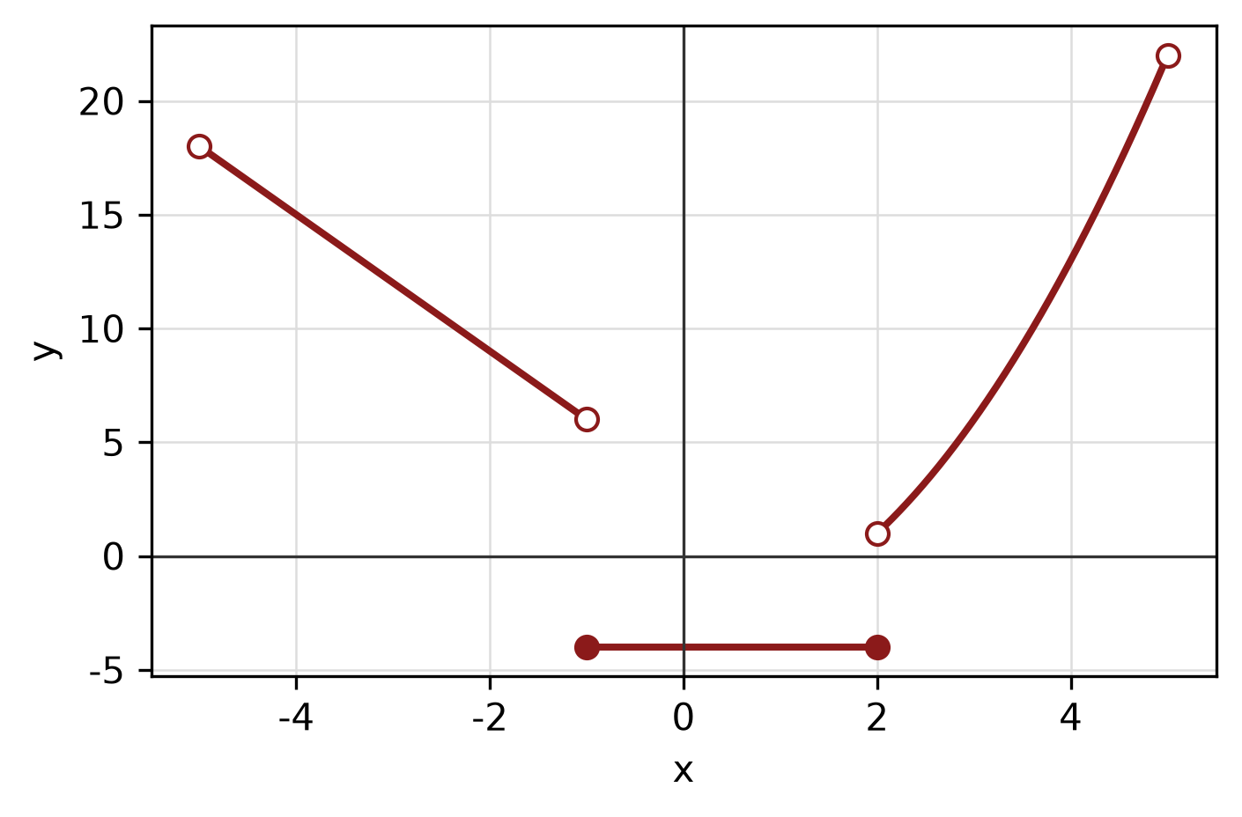
Figure: piecewise graph.
e) Apply graph-transformation techniques to sketch y = -2(x - 4)² - 5. State the vertex and the y-intercept.
(5 marks)
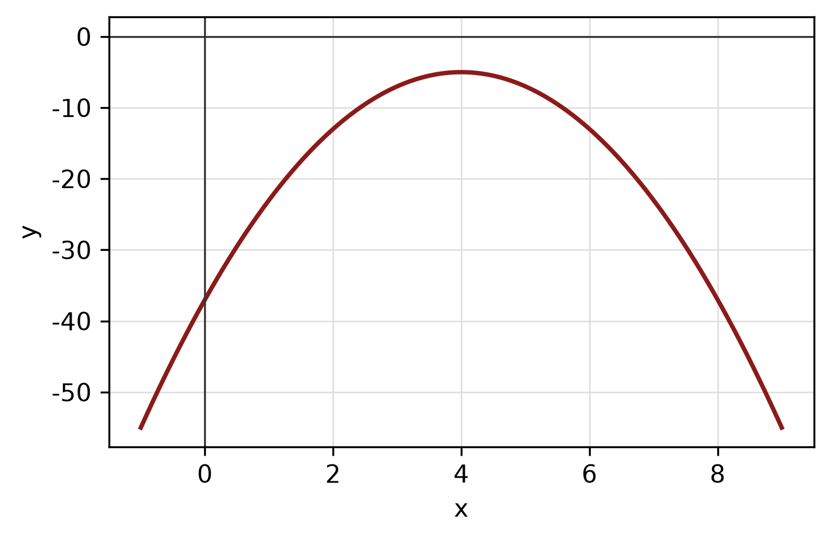
Figure: transformed graph.
f) Determine algebraically whether f(x) = 4x^5 - x^3 + 2x is even, odd or neither. State the symmetry of its graph.
(4 marks)
g) Given f(x) = -5x - 6 and g(x) = 2 - 2x, find (f + g)(x), (f - g)(x) and (f g)(x). State the domain of each.
(4 marks)
h) Sketch y = |x - 2| + 1 for -2 ≤ x ≤ 6. State the domain and range.
(4 marks)
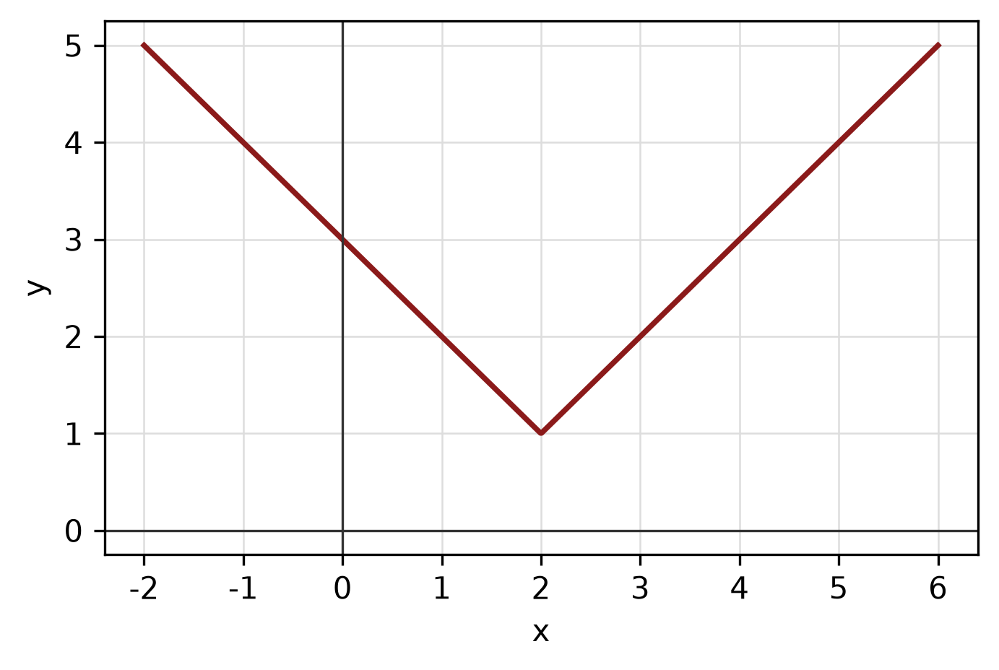
Figure: function graph.
QUESTION 2
a) Solve the inequality -x - 8 < 1. Express the answer in interval notation.
(4 marks)
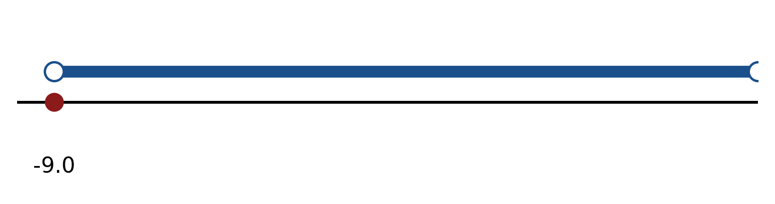
Figure: solution on a number line.
b) Solve the compound inequality -4 < 5 - 4x < 3. Express the answer in interval notation.
(4 marks)
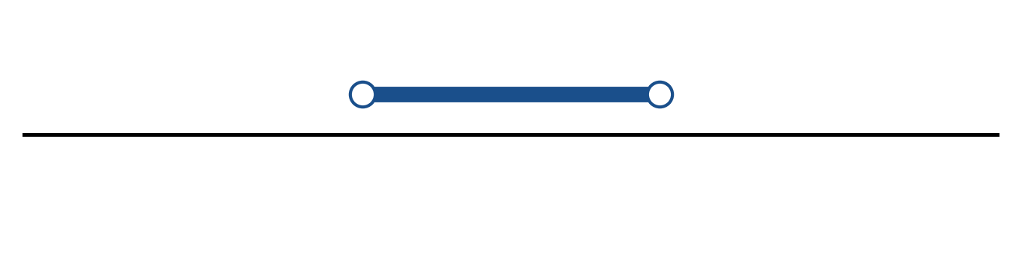
Figure: solution on a number line.
c) Solve the inequality -2x² + 8x + 10 <= 0.
(5 marks)
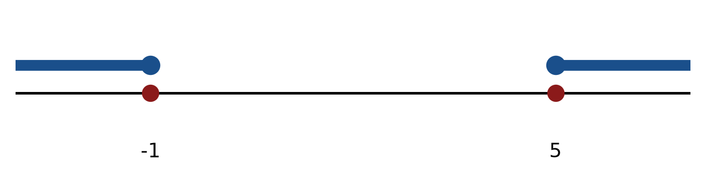
Figure: critical values.
d) Solve the rational inequality (5 - 3x)/(3x - 5) > -1. Express the answer in interval notation.
(5 marks)
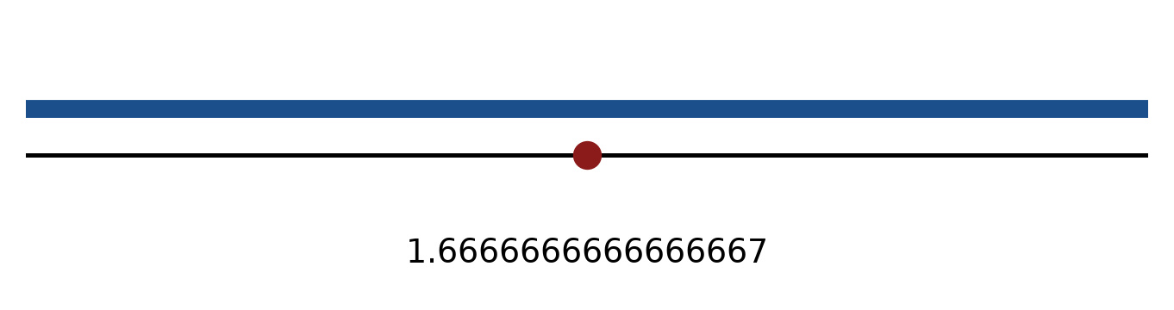
Figure: critical values.
e) Write the solution of 3x - 6 < -2 in interval notation and on a number line.
(3 marks)
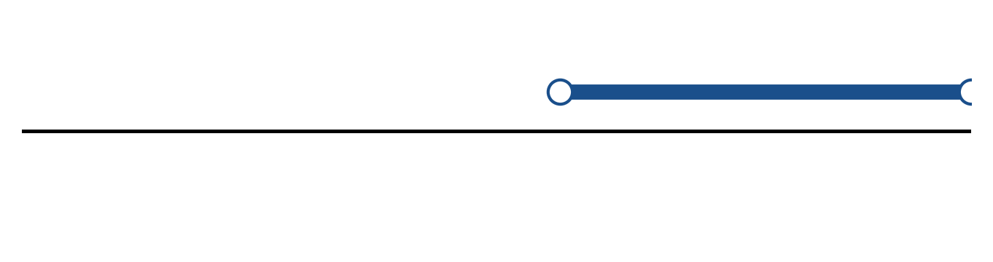
Figure: solution set.
QUESTION 3
a) Solve the equation |-5x - 1| = 5.
(4 marks)
b) Solve the inequality |5 - 4x| >= 7. Express the answer in interval notation and on a number line.
(5 marks)
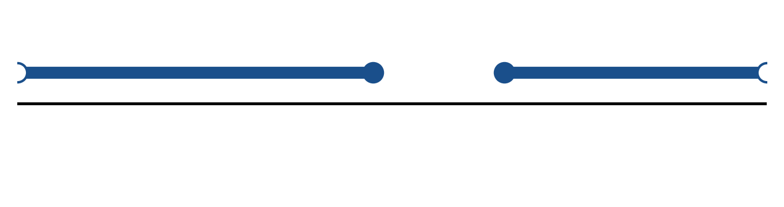
Figure: solution on a number line.
c) Sketch y = -3|x + 3| + 5. State the vertex, the y-intercept and any x-intercepts.
(5 marks)
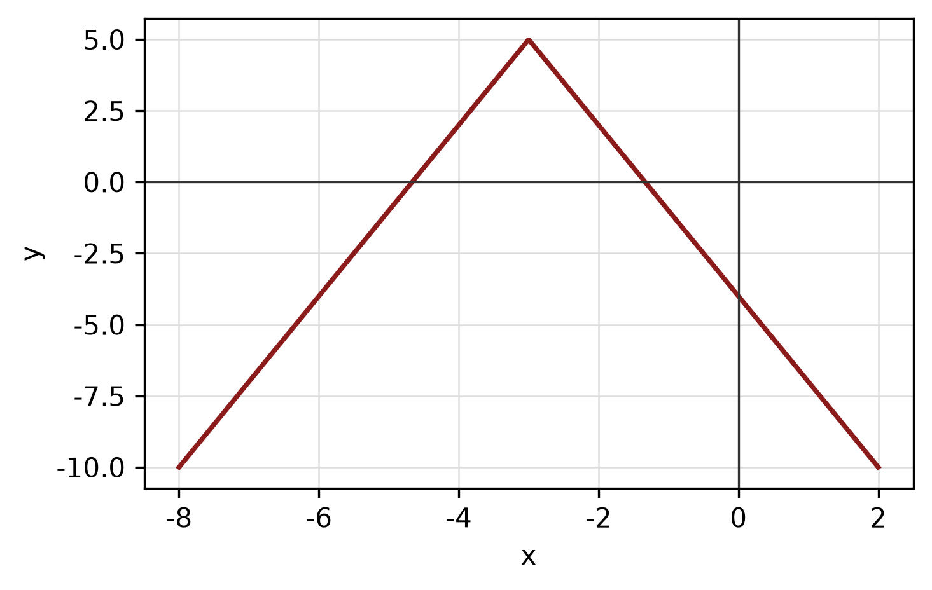
Figure: absolute-value graph.
END OF QUESTION PAPER

APPENDIX 1
Formula sheet (as supplied with the paper).
sin² A + cos² A = 1 | tan² A + 1 = sec² A
sin(A + B) = sin A cos B + cos A sin B | tan 2A = 2 tan A / (1 − tan² A)
cos(A + B) = cos A cos B − sin A sin B | Arc length, s = rθ
tan(A − B) = (tan A − tan B) / (1 + tan A tan B) | Area of sector = ½r²θ
cos 2A = cos² A − sin² A | a / sin A = b / sin B = c / sin C
cos 2A = 1 − 2sin² A = 2cos² A − 1 | a² = b² + c² − 2bc cos A
sin 2A = 2 sin A cos A | Area of triangle = ½ab sin C

